Irregular Rectilinear Shapes
# Source: AI Source: Provided by: [Data Path: Persons Table -> ID Column: 1, Name_En Column: Motasem Essam] -> From: [ChatGPT] on [7/25/2026]
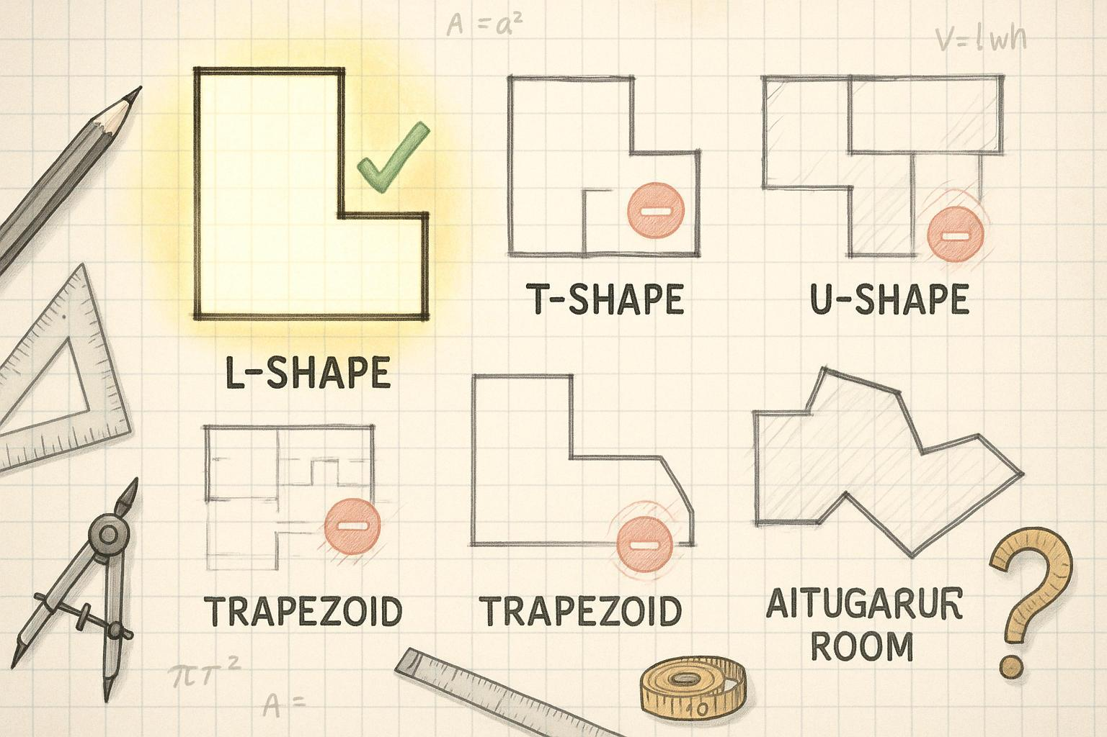

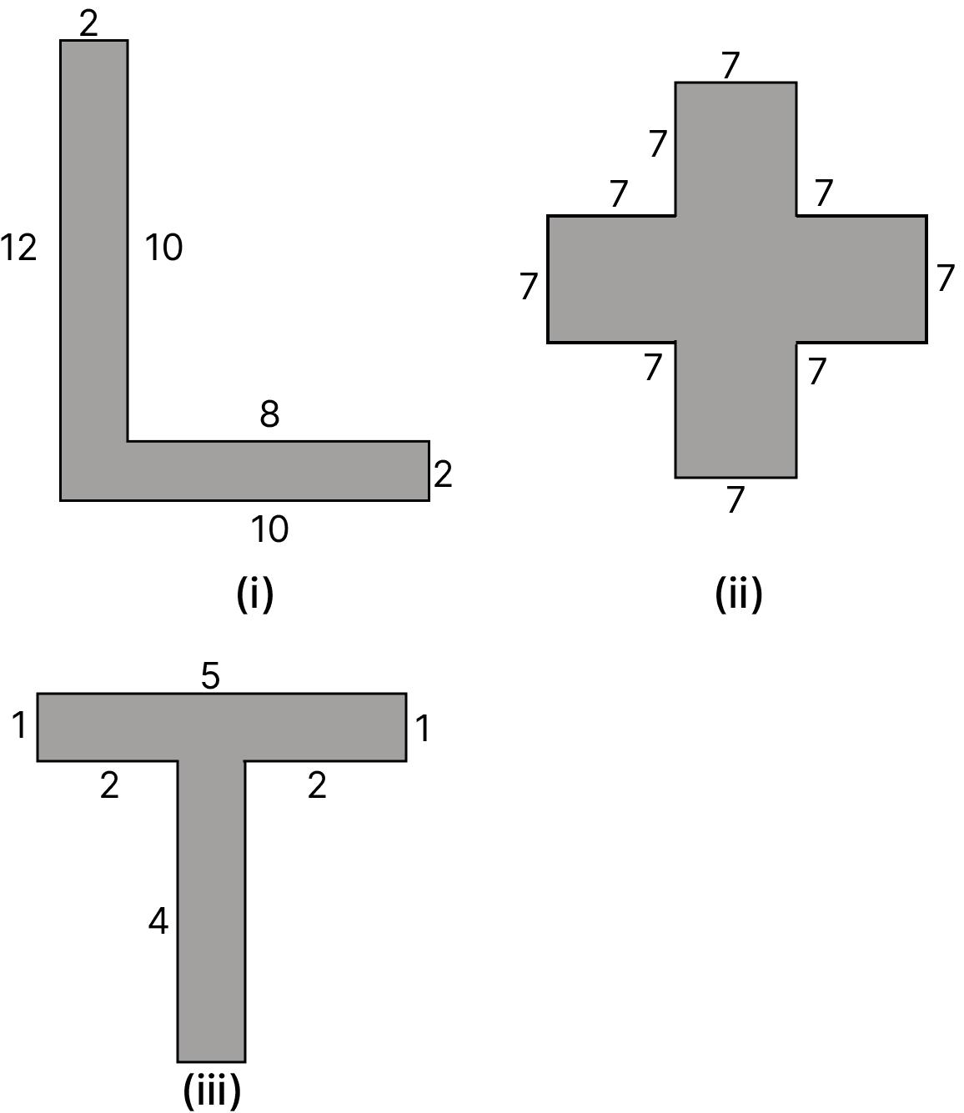
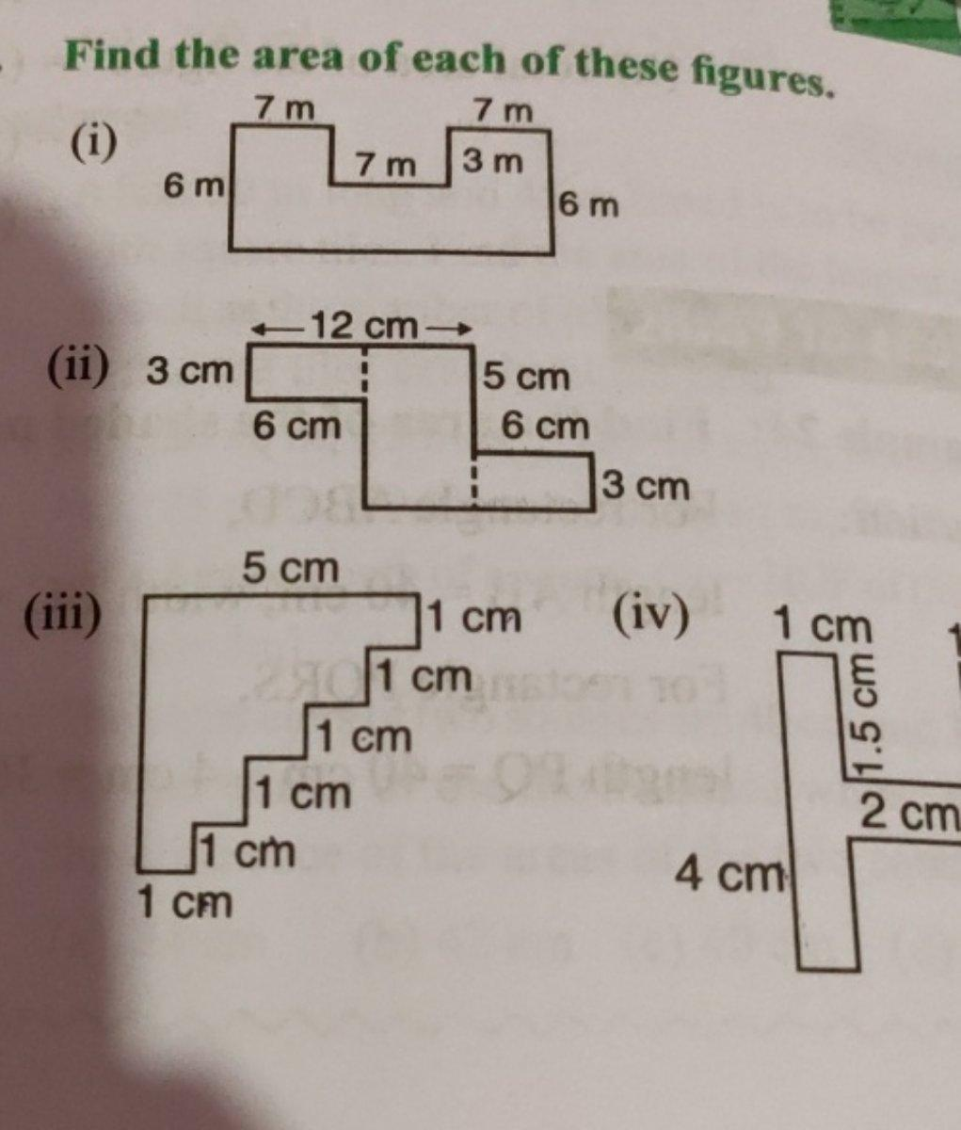

Definition
# Source: AI Source: Provided by: [Data Path: Persons Table -> ID Column: 1, Name_En Column: Motasem Essam] -> From: [ChatGPT] on [7/25/2026]
An Irregular Rectilinear Shape is a rectilinear shape that does not satisfy the conditions of a regular polygon.
A rectilinear shape has a boundary made entirely of straight line segments, normally arranged horizontally and vertically. An irregular rectilinear shape has unequal side lengths, unequal angles, or both.
$$\boxed{\text{Irregular Rectilinear Shape}=\text{Rectilinear Shape that is not regular}}$$
Because a rectilinear polygon can have only ${90}^{∘}$and ${270}^{∘}$interior angles, an irregular rectilinear polygon does not necessarily have unequal angles. It may have all ${90}^{∘}$angles but unequal side lengths, as in a non-square rectangle.

Fundamental Concept
# Source: AI Source: Provided by: [Data Path: Persons Table -> ID Column: 1, Name_En Column: Motasem Essam] -> From: [ChatGPT] on [7/25/2026]
A regular polygon requires:
$$\text{All sides equal}$$
and
$$\text{All interior angles equal}$$
A rectilinear polygon requires its edges to be horizontal or vertical.
Therefore, a rectilinear polygon is irregular when it does not have the regular-polygon property.
Examples
A rectangle with:
$$w≠h$$
is irregular because its sides are not all equal, even though all its angles are ${90}^{∘}$.
An L-shaped region is also irregular and is additionally concave.

Main Characteristics
# Source: AI Source: Provided by: [Data Path: Persons Table -> ID Column: 1, Name_En Column: Motasem Essam] -> From: [ChatGPT] on [7/25/2026]
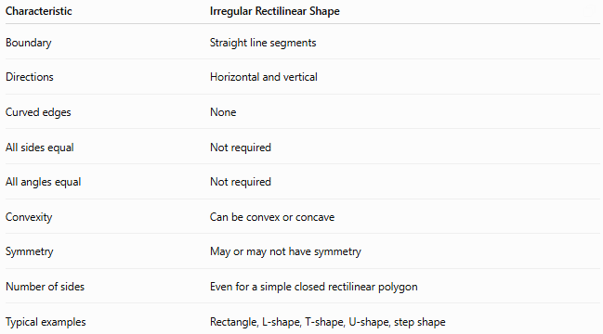
Characteristic | Irregular Rectilinear Shape
Boundary | Straight line segments
Directions | Horizontal and vertical
Curved edges | None
All sides equal | Not required
All angles equal | Not required
Convexity | Can be convex or concave
Symmetry | May or may not have symmetry
Number of sides | Even for a simple closed rectilinear polygon
Typical examples | Rectangle, L-shape, T-shape, U-shape, step shape

Classification
# Source: AI Source: Provided by: [Data Path: Persons Table -> ID Column: 1, Name_En Column: Motasem Essam] -> From: [ChatGPT] on [7/25/2026]
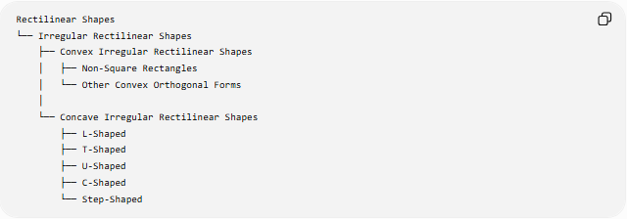
Rectilinear Shapes
└── Irregular Rectilinear Shapes
├── Convex Irregular Rectilinear Shapes
│ ├── Non-Square Rectangles
│ └── Other Convex Orthogonal Forms
│
└── Concave Irregular Rectilinear Shapes
├── L-Shaped
├── T-Shaped
├── U-Shaped
├── C-Shaped
└── Step-Shaped
A more general structural classification is:
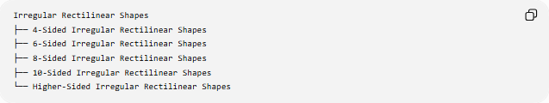
Irregular Rectilinear Shapes
├── 4-Sided Irregular Rectilinear Shapes
├── 6-Sided Irregular Rectilinear Shapes
├── 8-Sided Irregular Rectilinear Shapes
├── 10-Sided Irregular Rectilinear Shapes
└── Higher-Sided Irregular Rectilinear Shapes

Convex Irregular Rectilinear Shapes
# Source: AI Source: Provided by: [Data Path: Persons Table -> ID Column: 1, Name_En Column: Motasem Essam] -> From: [ChatGPT] on [7/25/2026]
A convex irregular rectilinear polygon has no inward indentation.
For a simple rectilinear polygon, however, a convex rectilinear polygon must be a rectangle.
Therefore, the standard convex irregular case is:
$$\boxed{\text{Non-square rectangle}}$$
Example:
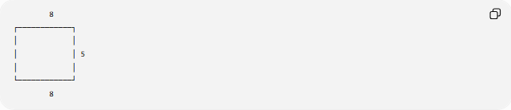
8
┌────────────┐
│ │
│ │ 5
│ │
└────────────┘
8
It has:
$$8, 8, 5, 5$$
as side lengths, so its sides are not all equal.
All four interior angles are still:
$${90}^{∘}$$
Thus it is rectilinear, convex, and irregular.

Concave Irregular Rectilinear Shapes
# Source: AI Source: Provided by: [Data Path: Persons Table -> ID Column: 1, Name_En Column: Motasem Essam] -> From: [ChatGPT] on [7/25/2026]
A concave irregular rectilinear shape has at least one inward indentation.
Examples include:
- L-shaped shapes
- T-shaped shapes
- U-shaped shapes
- C-shaped shapes
- step-shaped shapes
Example:
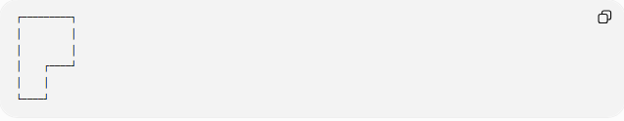
┌─────────┐
│ │
│ │
│ ┌────┘
│ │
└────┘
Such a shape contains at least one reflex interior angle:
$$\boxed{{270}^{∘}}$$
and its side lengths are generally not all equal.

Side-Length Properties
# Source: AI Source: Provided by: [Data Path: Persons Table -> ID Column: 1, Name_En Column: Motasem Essam] -> From: [ChatGPT] on [7/25/2026]
Irregular rectilinear shapes do not require all sides to have the same length.
For example:
$$AB≠BC≠CD$$
may occur.
However, a closed rectilinear polygon must satisfy directional closure.
Horizontal lengths
$$\boxed{\text{Total rightward length}=\text{Total leftward length}}$$
Vertical lengths
$$\boxed{\text{Total upward length}=\text{Total downward length}}$$
These relationships are useful for finding unknown side lengths.

Interior Angles
# Source: AI Source: Provided by: [Data Path: Persons Table -> ID Column: 1, Name_En Column: Motasem Essam] -> From: [ChatGPT] on [7/25/2026]
For a simple rectilinear polygon, interior angles are:
$${90}^{∘}$$
or:
$${270}^{∘}$$
A convex irregular rectilinear polygon, such as a non-square rectangle, has only:
$${90}^{∘}$$
angles.
A concave irregular rectilinear polygon has one or more:
$${270}^{∘}$$
angles.

Number of Sides
# Source: AI Source: Provided by: [Data Path: Persons Table -> ID Column: 1, Name_En Column: Motasem Essam] -> From: [ChatGPT] on [7/25/2026]
A simple closed rectilinear polygon has an even number of sides:
$$\boxed{n=4,6,8,10,…}$$
Therefore, irregular rectilinear polygons can have:
- 4 sides
- 6 sides
- 8 sides
- 10 sides
- and so on.
The 4-sided irregular case includes a non-square rectangle.
For concave rectilinear polygons, the minimum is:
$$\boxed{6\text{ sides}}$$

Area
# Source: AI Source: Provided by: [Data Path: Persons Table -> ID Column: 1, Name_En Column: Motasem Essam] -> From: [ChatGPT] on [7/25/2026]
The area of an irregular rectilinear shape can usually be calculated by dividing it into rectangles.
Addition method
$$\boxed{A=A_{1}+A_{2}+⋯+A_{n}}$$
Subtraction method
Start with a larger rectangle and subtract the missing portions:
$$\boxed{A=A_{\text{outer}}-A_{\text{removed}}}$$
This is particularly useful for L-, U-, C-, and step-shaped regions.

Perimeter
# Source: AI Source: Provided by: [Data Path: Persons Table -> ID Column: 1, Name_En Column: Motasem Essam] -> From: [ChatGPT] on [7/25/2026]
The perimeter is the sum of all boundary segments:
$$\boxed{P=l_{1}+l_{2}+⋯+l_{n}}$$
For example, if an irregular rectilinear polygon has side lengths
$$a,b,c,d,e,f$$
then:
$$P=a+b+c+d+e+f$$

Regular vs. Irregular Rectilinear Shapes
# Source: AI Source: Provided by: [Data Path: Persons Table -> ID Column: 1, Name_En Column: Motasem Essam] -> From: [ChatGPT] on [7/25/2026]
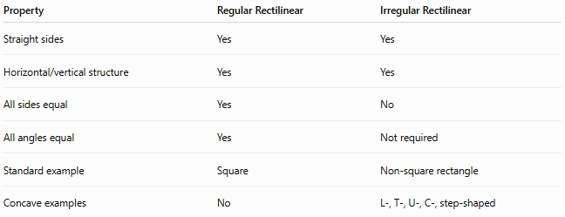
Property | Regular Rectilinear | Irregular Rectilinear
Straight sides | Yes | Yes
Horizontal/vertical structure | Yes | Yes
All sides equal | Yes | No
All angles equal | Yes | Not required
Standard example | Square | Non-square rectangle
Concave examples | No | L-, T-, U-, C-, step-shaped
The key difference is:
$$\boxed{\text{Regular}→\text{equal sides and equal angles}}$$
while:
$$\boxed{\text{Irregular}→\text{does not satisfy both conditions}}$$

Irregular Rectilinear vs. Concave Rectilinear
# Source: AI Source: Provided by: [Data Path: Persons Table -> ID Column: 1, Name_En Column: Motasem Essam] -> From: [ChatGPT] on [7/25/2026]
These are not synonyms.
Irregular Rectilinear
Describes the regularity of the shape.
Concave Rectilinear
Describes the convexity of the shape.
Therefore, a shape can be:
- irregular and convex
- irregular and concave
For example:
$$\boxed{\text{Non-square rectangle}=\text{Irregular + Convex + Rectilinear}}$$
while:
$$\boxed{\text{L-shape}=\text{Irregular + Concave + Rectilinear}}$$

Irregular Rectilinear vs. Freeform
# Source: AI Source: Provided by: [Data Path: Persons Table -> ID Column: 1, Name_En Column: Motasem Essam] -> From: [ChatGPT] on [7/25/2026]
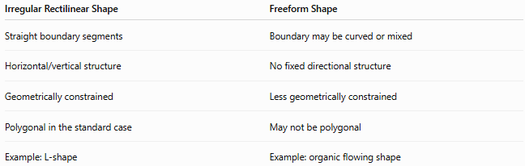
Irregular Rectilinear Shape | Freeform Shape
Straight boundary segments | Boundary may be curved or mixed
Horizontal/vertical structure | No fixed directional structure
Geometrically constrained | Less geometrically constrained
Polygonal in the standard case | May not be polygonal
Example: L-shape | Example: organic flowing shape
Therefore:
$$\boxed{\text{Irregular}≠\text{Freeform}}$$
An irregular rectilinear shape is still strongly constrained by its horizontal and vertical edges.

Mathematical Classification Tree
# Source: AI Source: Provided by: [Data Path: Persons Table -> ID Column: 1, Name_En Column: Motasem Essam] -> From: [ChatGPT] on [7/25/2026]
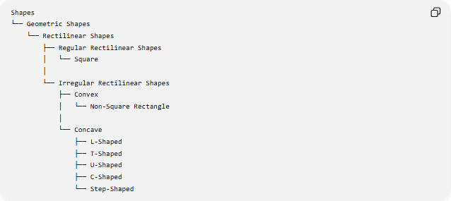
Shapes
└── Geometric Shapes
└── Rectilinear Shapes
├── Regular Rectilinear Shapes
│ └── Square
│
└── Irregular Rectilinear Shapes
├── Convex
│ └── Non-Square Rectangle
│
└── Concave
├── L-Shaped
├── T-Shaped
├── U-Shaped
├── C-Shaped
└── Step-Shaped

Example
# Source: AI Source: Provided by: [Data Path: Persons Table -> ID Column: 1, Name_En Column: Motasem Essam] -> From: [ChatGPT] on [7/25/2026]
Consider a 6-sided L-shaped rectilinear polygon.
It can have side lengths such as:
$$10, 4, 6, 3, 4, 7$$
The sides are not all equal, so the polygon is irregular.
Its angle structure contains:
- five ${90}^{∘}$angles
- one ${270}^{∘}$angle
The interior-angle sum is:
$$\left(6-2\right){180}^{∘}={720}^{∘}$$
and:
$$5\left({90}^{∘}\right)+{270}^{∘}={720}^{∘}$$

Key Points
# Source: AI Source: Provided by: [Data Path: Persons Table -> ID Column: 1, Name_En Column: Motasem Essam] -> From: [ChatGPT] on [7/25/2026]
- An Irregular Rectilinear Shape is a rectilinear shape that is not regular.
- Its boundary consists of straight horizontal and vertical segments.
- Its sides do not all have to be equal.
- Its angles do not all have to be equal.
- A non-square rectangle is an irregular convex rectilinear shape.
- L-, T-, U-, C-, and step-shaped regions are irregular concave rectilinear shapes.
- A simple closed rectilinear polygon has an even number of sides.
- Its area can commonly be found through rectangle decomposition.
- Irregularity describes equality/regularity, while concavity describes inward indentation.

Conclusion
# Source: AI Source: Provided by: [Data Path: Persons Table -> ID Column: 1, Name_En Column: Motasem Essam] -> From: [ChatGPT] on [7/25/2026]
An Irregular Rectilinear Shape is a rectilinear shape that does not have the equal-side-and-equal-angle properties required of a regular polygon. It may be convex, such as a non-square rectangle, or concave, such as an L-shaped or U-shaped region.
$$\boxed{\text{Irregular Rectilinear Shape}=\text{Rectilinear Shape without Regularity}}$$

